*AN AWARD WINNER INTERNATIONAL ORGANIZATION*

a Im



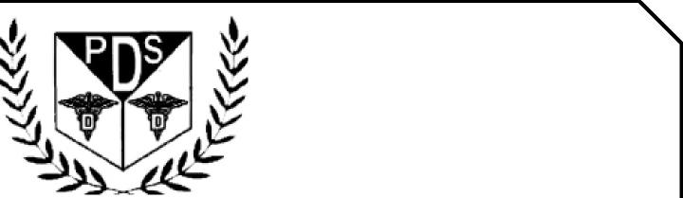

PROMOTING EXCELLENCE IN DENTAL EDUCATION   
Over 7000 Members Strong

**Presents**

BUILD DENTAL PRACTICE WITH ALIGNERS

**Louis Chmura, DDS, MS**

**On   
August 24, 2025 (Sunday) 8:00am till 12:00am   
(CA Board 4 hrs C.E. units)   
at**



**ONLINE WEBINAR**

(Please print in capital letters or attach your business card)

Name DR/RDH/RDA/DA Lic no

|  |  |  |  |
| --- | --- | --- | --- |
| Circle one First Middle Initial Last | |  |  |
| Address |  |  |  |

City State Zip

Cell no _____________________________ E-Mail_______________________________________________

**ARE YOU A PDS MEMBER: YES/ NO**

|  |  |  |
| --- | --- | --- |
| REGISTRATION FEE |  |  |
| Dentists Non-members | $50.00 |  |
| Members | $40.00 |  |
| Hygienist/R.D.A. Non-members | $40.00 |  |
| Members | $35.00 |  |

FOR REGISTRATION

CALL TOLL FREE 1-866-422-5573 (1-866-4-CALL-PDS) OR 909-933-9076   
**TO REGISTER ONLINE VISIT US ON WWW** [**PDSOCIETY. COM**](http://PDSOCIETY.COM)

Make check payable to

Dr. R. Salwan

President



PDS

124 EAST F STREET SUITE #8 ONTARIO, CA 91764

Dr. D.P. Singh Nagra

Chairman



**Webinar Date & Time:**

**Sunday, August 24, 2025, 8:00 AM - 12:00 AM Pacific Time (US & Canada)**

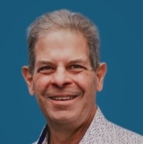**Duration: 4 Hours**

**Louis Chmura, DDS, MS**

Dr. Chmura is an early adopter and an innovator in orthodontics who has participated in over 10,000 hours of orthodontic education, served as an advisor to numerous companies, and has been involved in developing practical courses to help orthodontists incorporate soft tissue lasers, 3D CBCT, and screening, testing, and treatment of obstructive sleep apnea in the orthodontic office. With numerous professional publications and over 100 professional presentations, Dr. Chmura is passionate about helping others see possibilities beyond their current situation.

• In private practice for 35 years in Michigan

• Consultant specialized in aligner treatment & airway-centered orthodontics

• FXCollaboration orthodontist

THIS EVENT IS SPONSORED BY PDS AND DOWELL DENTAL

